# Unlocking Insights into the Global Air Transportation Network with Tableau

# 1. Introduction

1.1 Overview

The air Transport system generally includes airports. Air traffic control system and airlines. The airports represent the ground part of the system’s infrastructures handing the aircrafts operated by different airlines transporting passengers and freight/cargo shipments.

1.2 Purpose

Air transport is one of the fastest modes of public transport which connects international boundaries. Air transport allows people from different countries to cross international boundaries and travel other countries for personal, business , medical and tourism purposes.

# 2. Problem statement and design thinking

Clearly define the problem you want to address., ”Understanding and unlocking insights into the global air transportation network with tableau’’

### 2.1 Empathy map

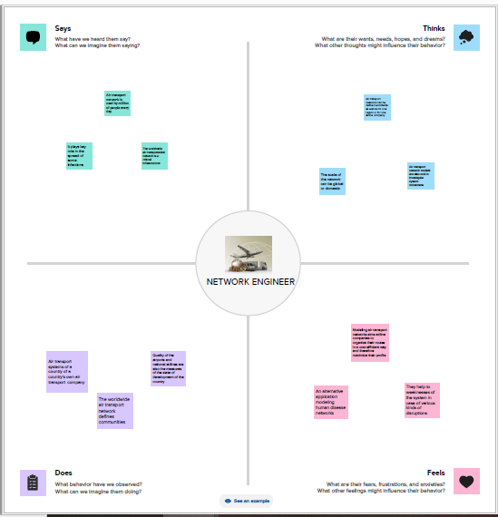

2.2 Brainstorming ideas and Prioritization

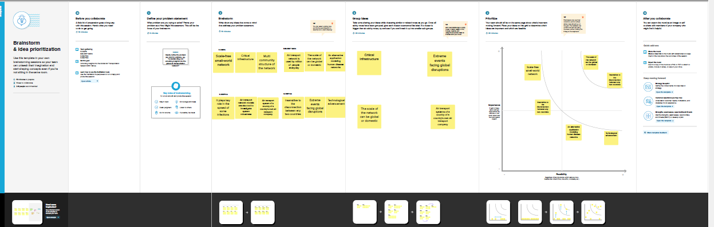

# 3.Result

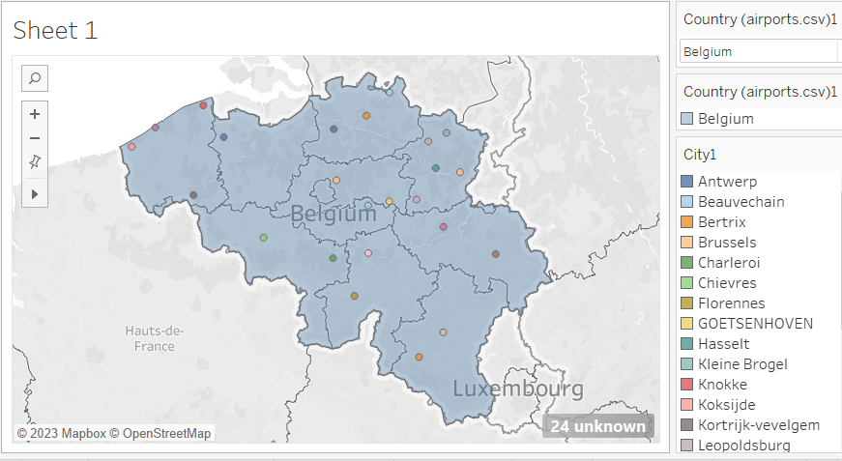

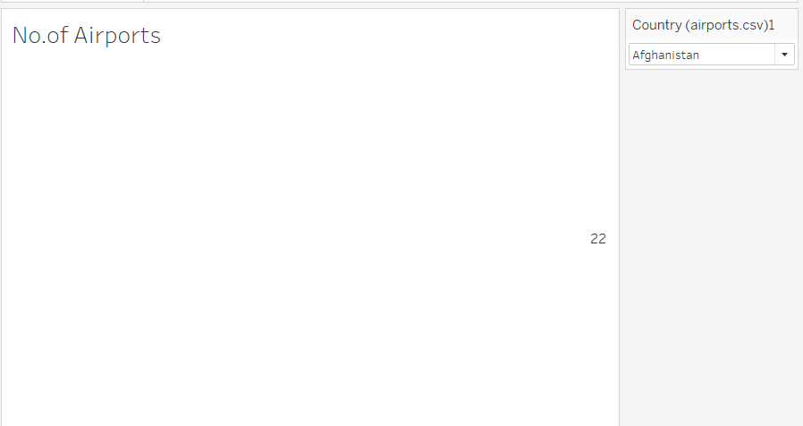

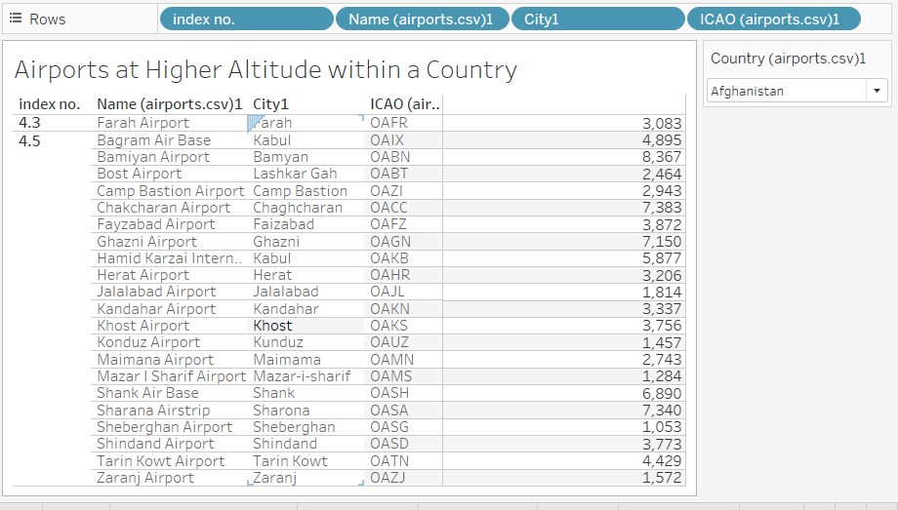

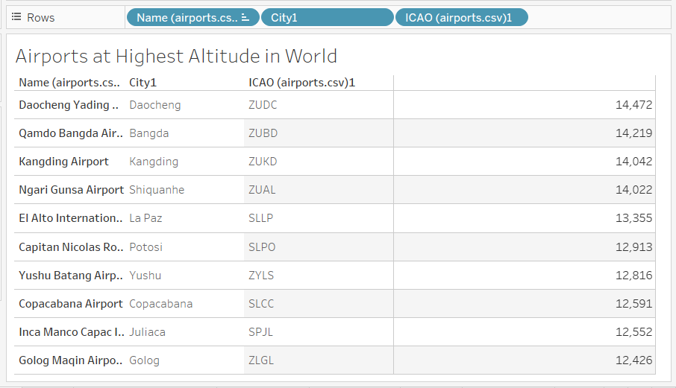

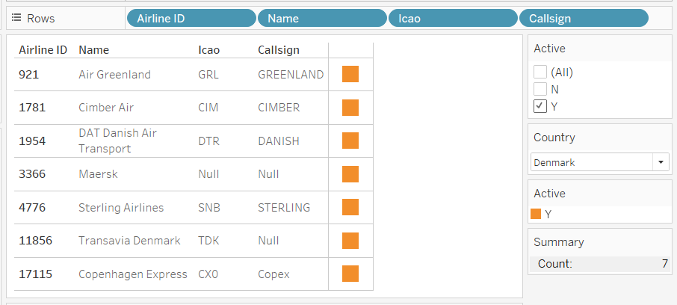

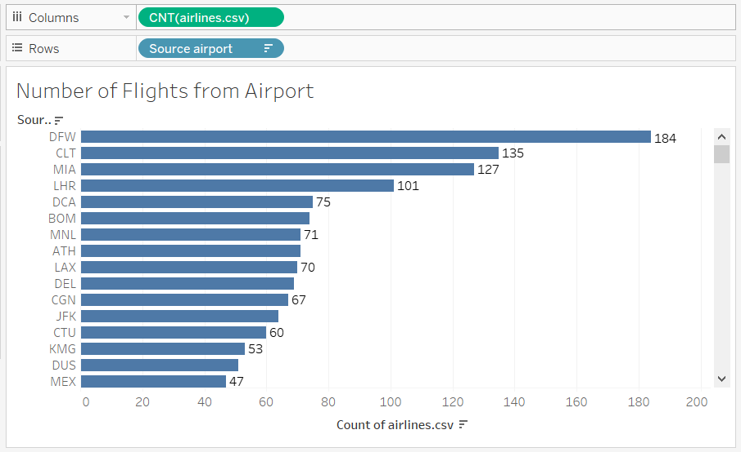

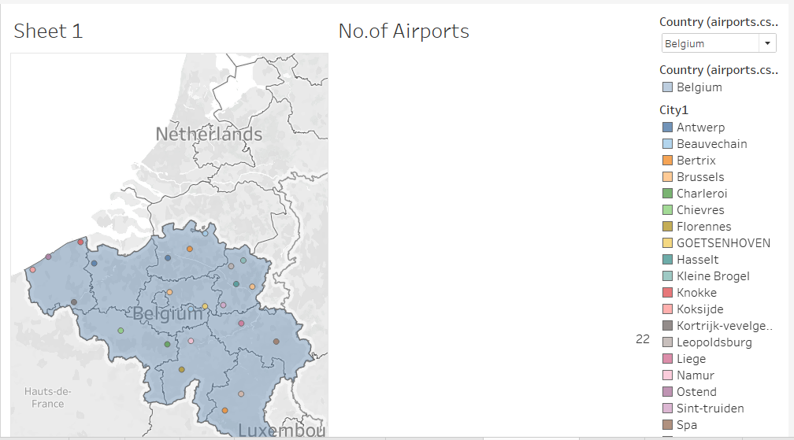

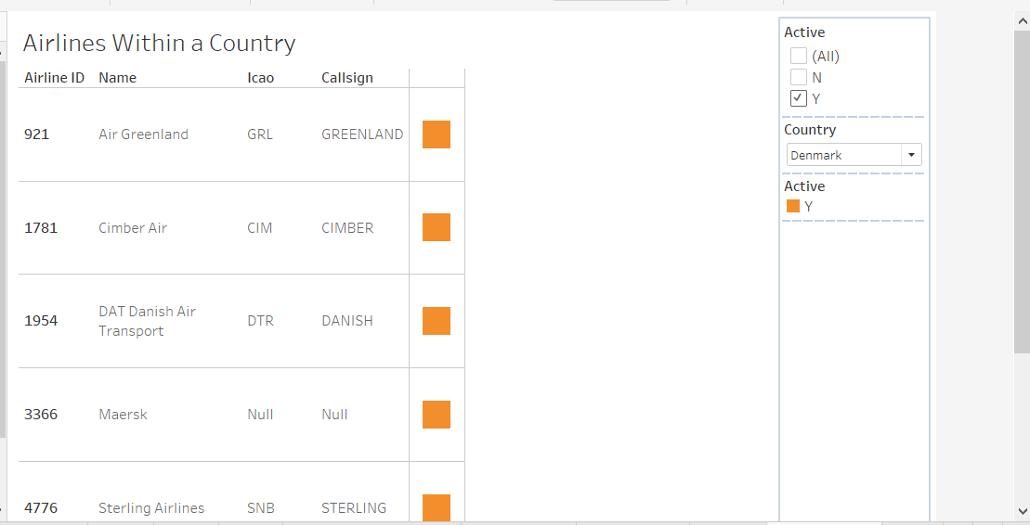

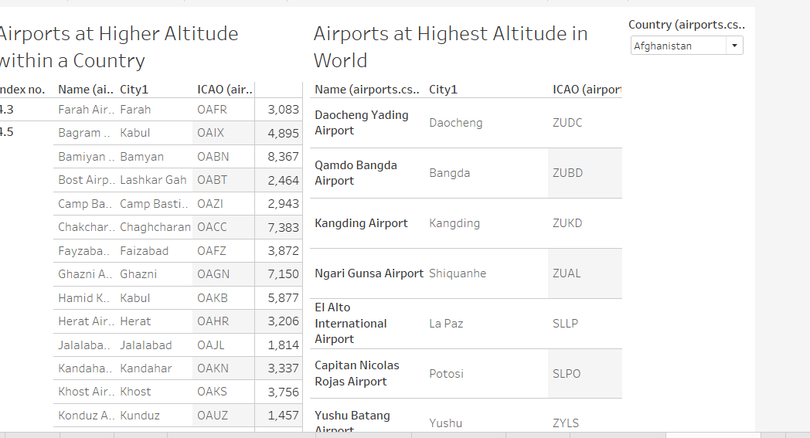

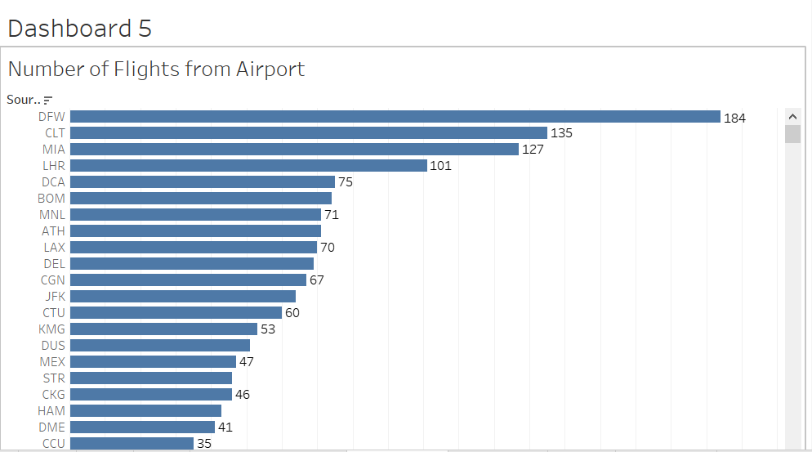

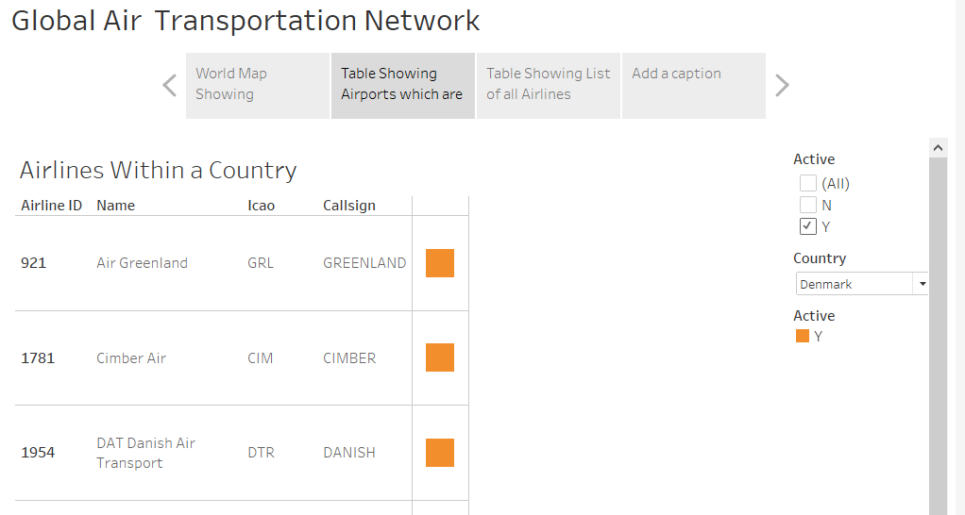

# 4. Advantages & Disadvantage

Advantages Disadvantages

No physical limits Risky

Very reliable transportation Limited Capacity

Long distances Large investment

Higher cost Accident prone

# 5. Application

Air transport networks aims airline comparies to organize their routes in a cost efficient way and therefore maximize their profits. Air transport networks models are also the tool to investigate systems robustness.

# 6.conclution

As the industry continues to evolve, IATA will remain an important player in shaping the future of air transport. In conclusion, the international Air Transport Association has been instrumental in developing and improving the air transport industry.

# 7. future scope

The industry has a number of domestic and international airlines, as well as large network of airports. The future of the aviation industry in india is likely to see continued growth and expansion, driven by factors such as a growing middle class, increased tourism and government policies supporting the industry.